1. Watch terraform-03 video.   
     
   ---Done  
     
   2) Execute the script shown in video.   
     
   1)**--->>> Variable.tf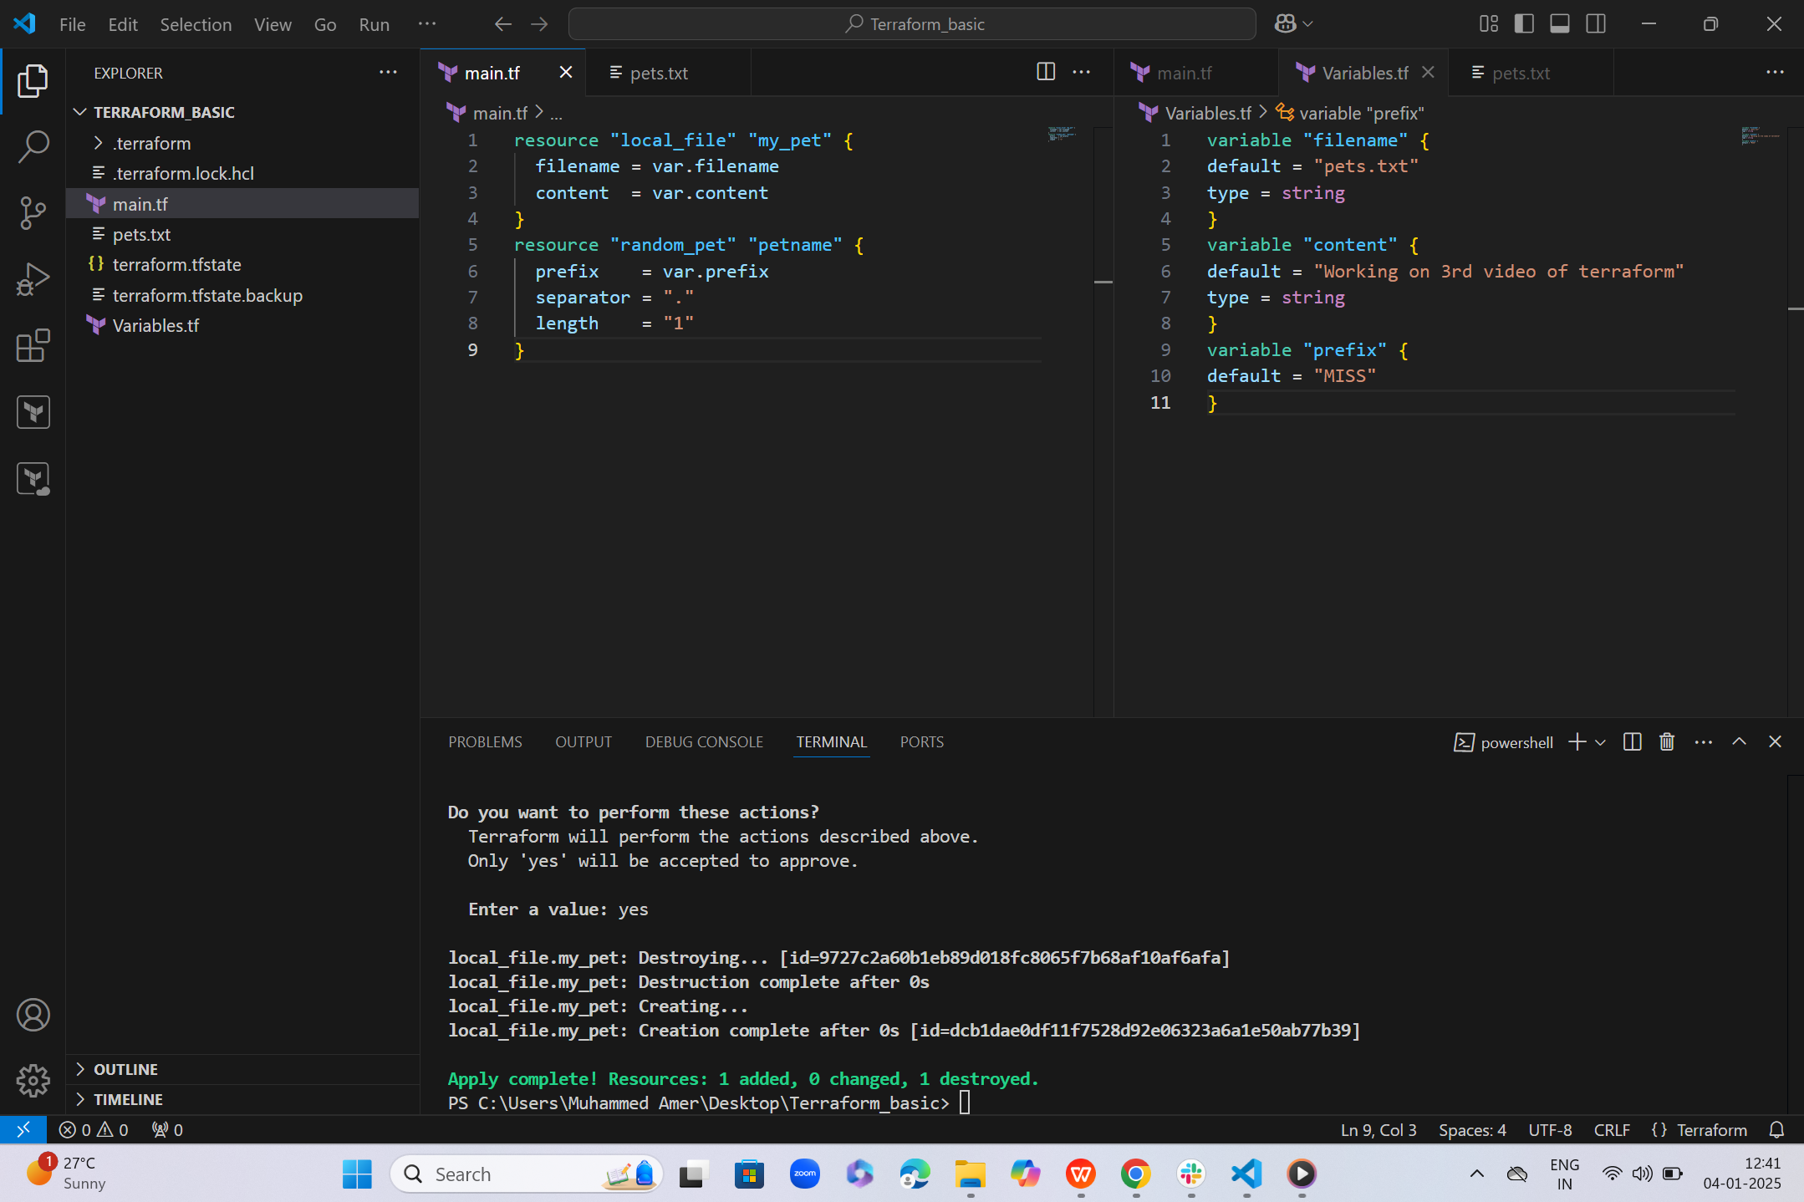 2) --->>> Interactive model--**  
   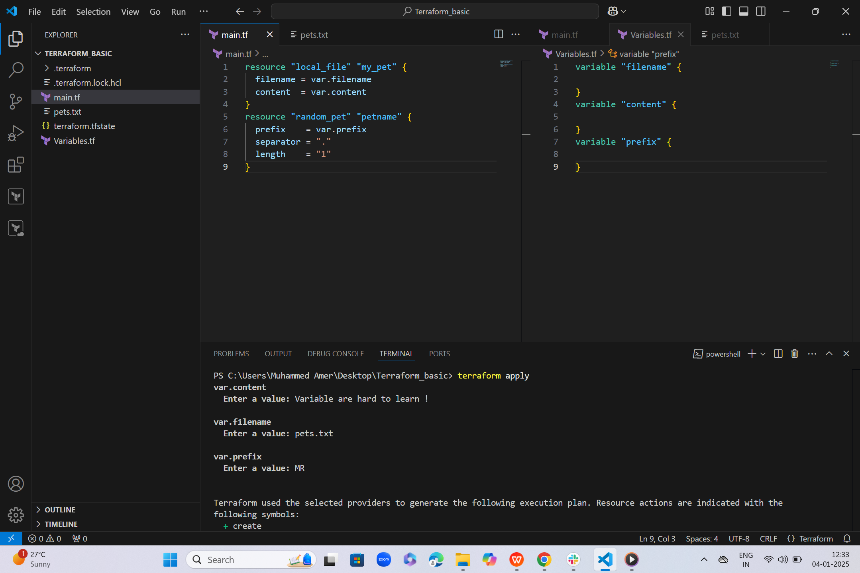  
   **3) ------>>> Command-line flags**  
     
   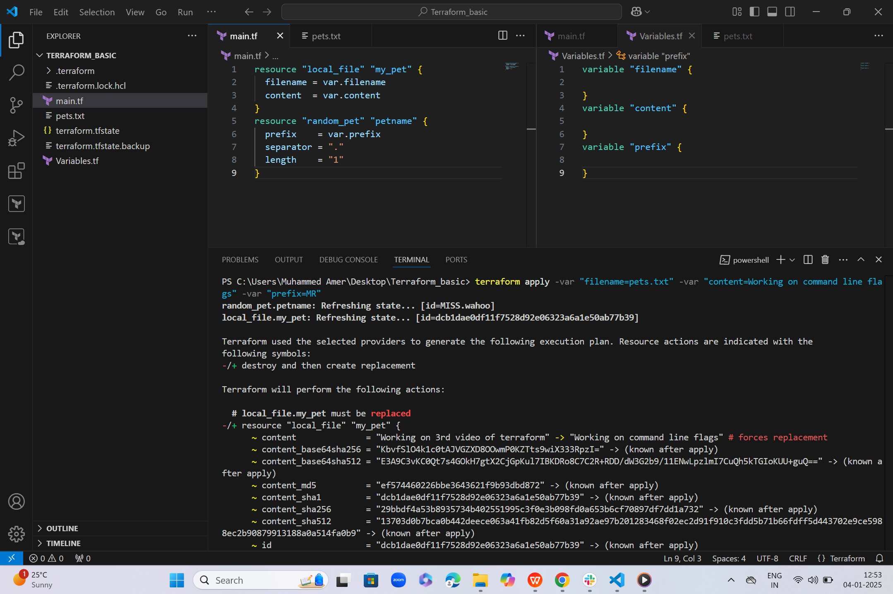  
     
     
     
   **4) ------->>> Environment Variables**  
     
   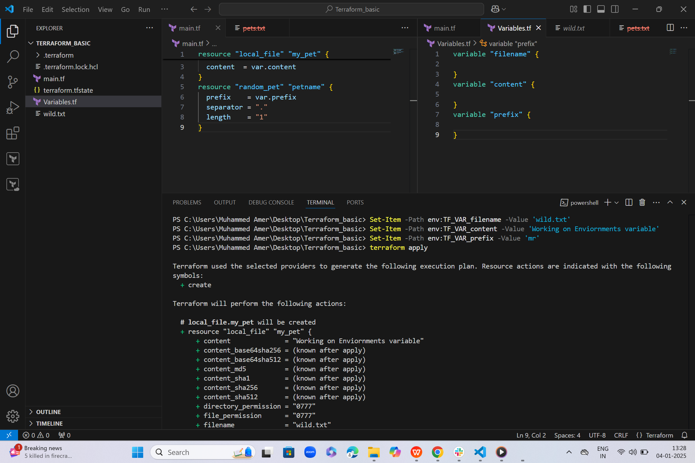  
     
     
     
     
   5) Variable definition file  
     
     
   **Precedence-Order  
   ENV --> V.TF -- > Auto.tf --> CLF**  
     
   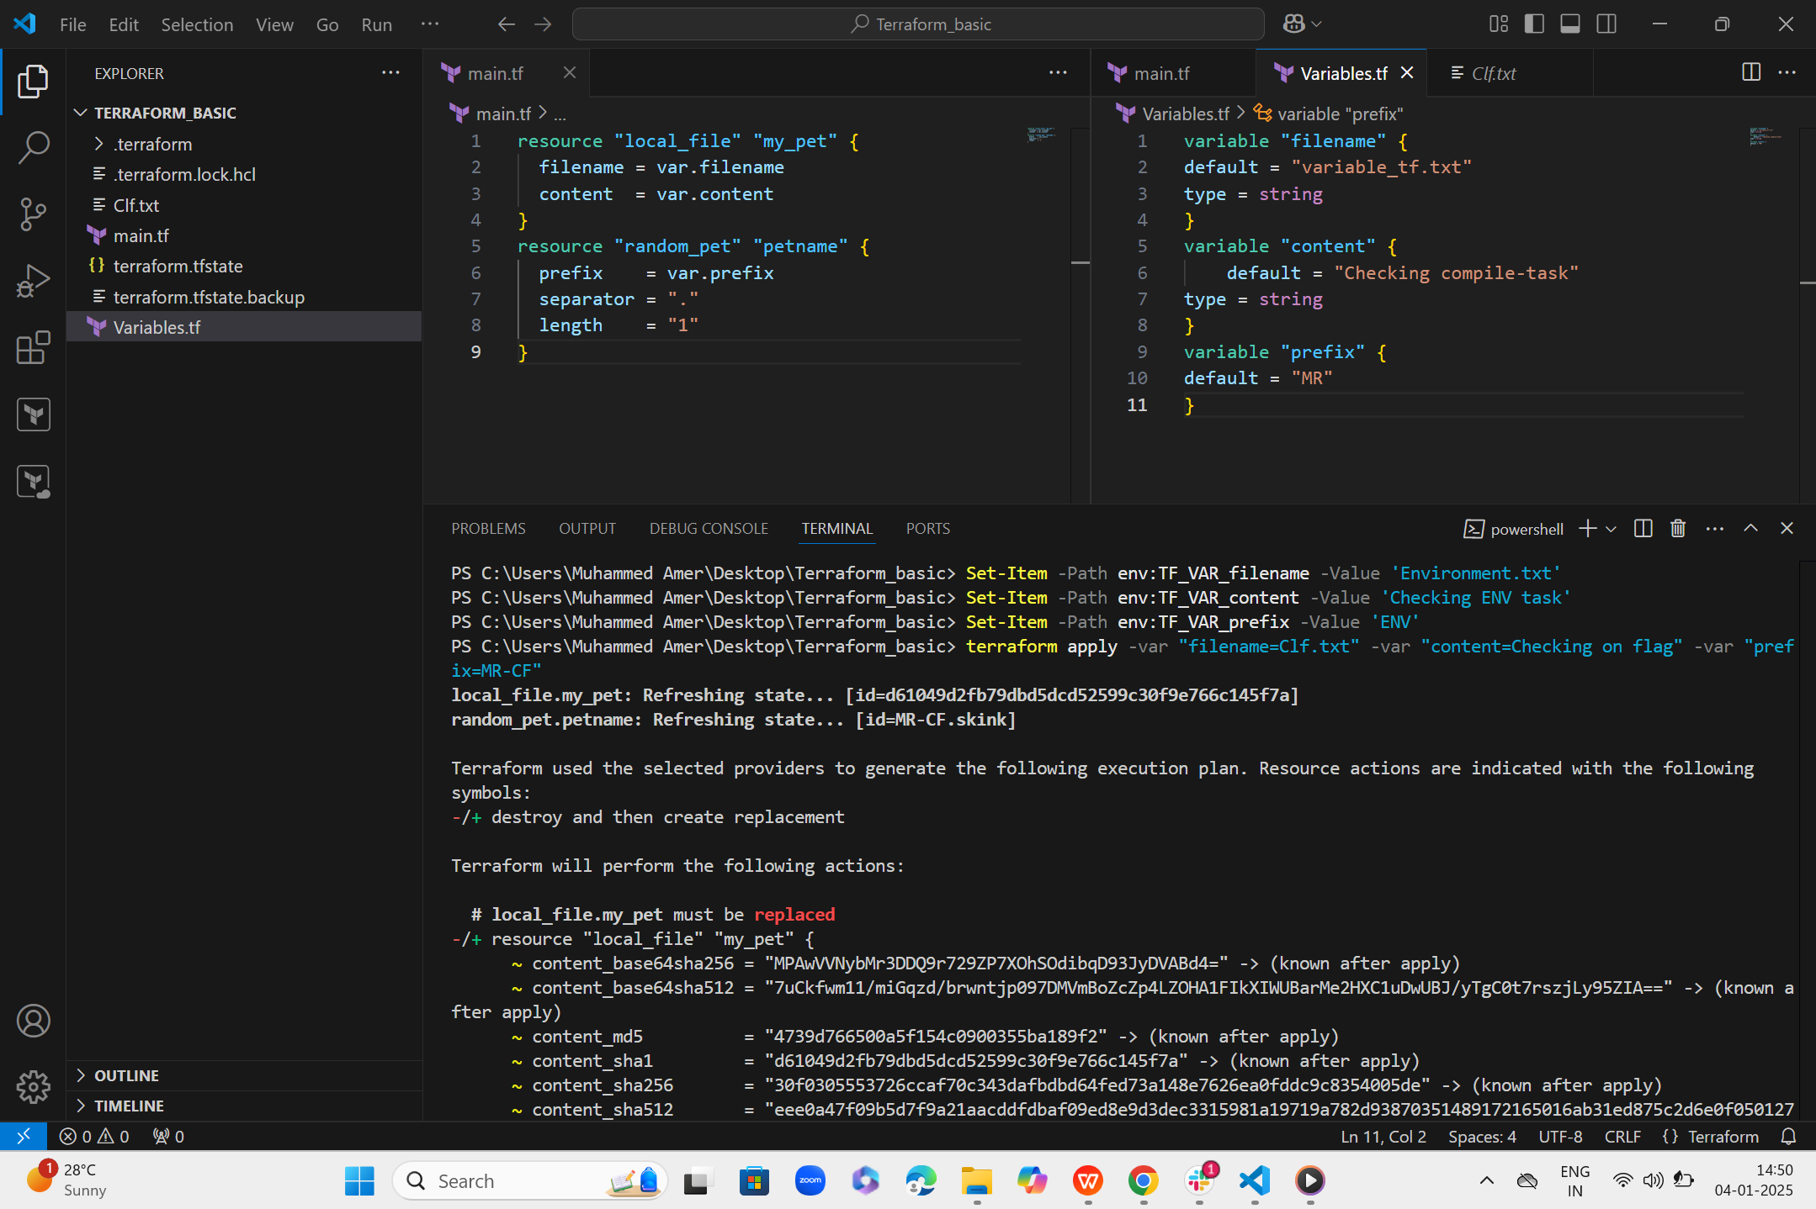  
     
     
     
     
   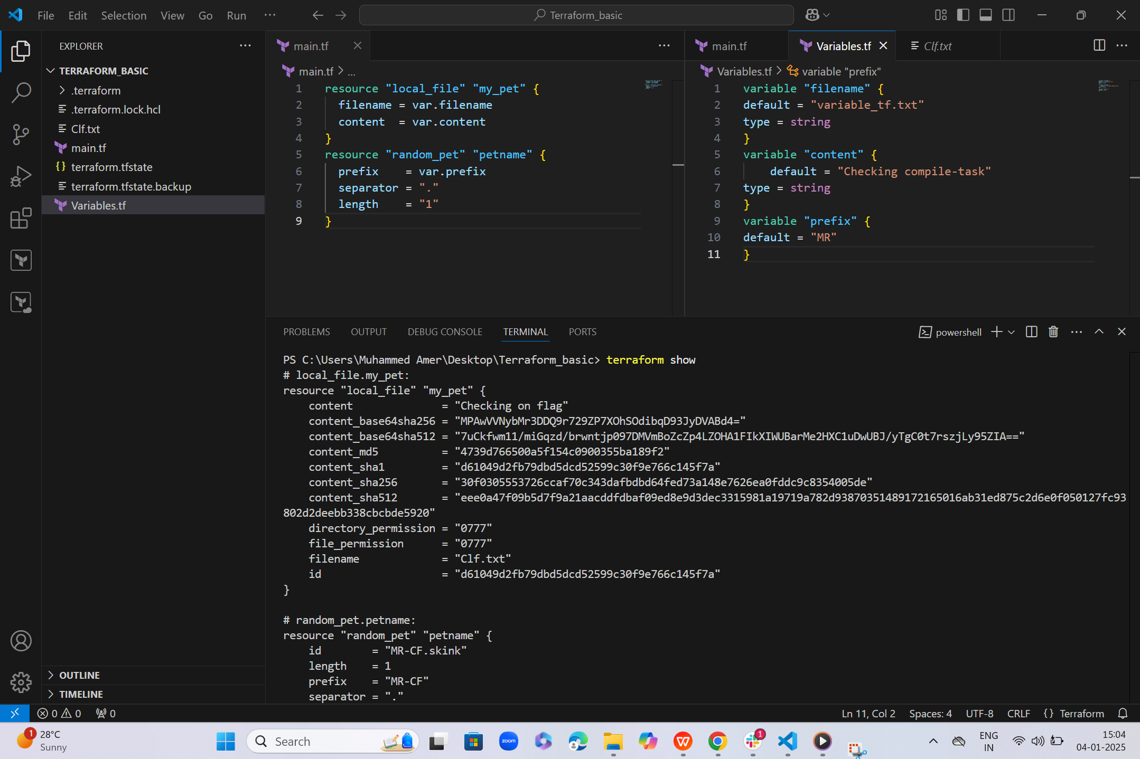  
     
   **Compiling two resource providers**  
     
   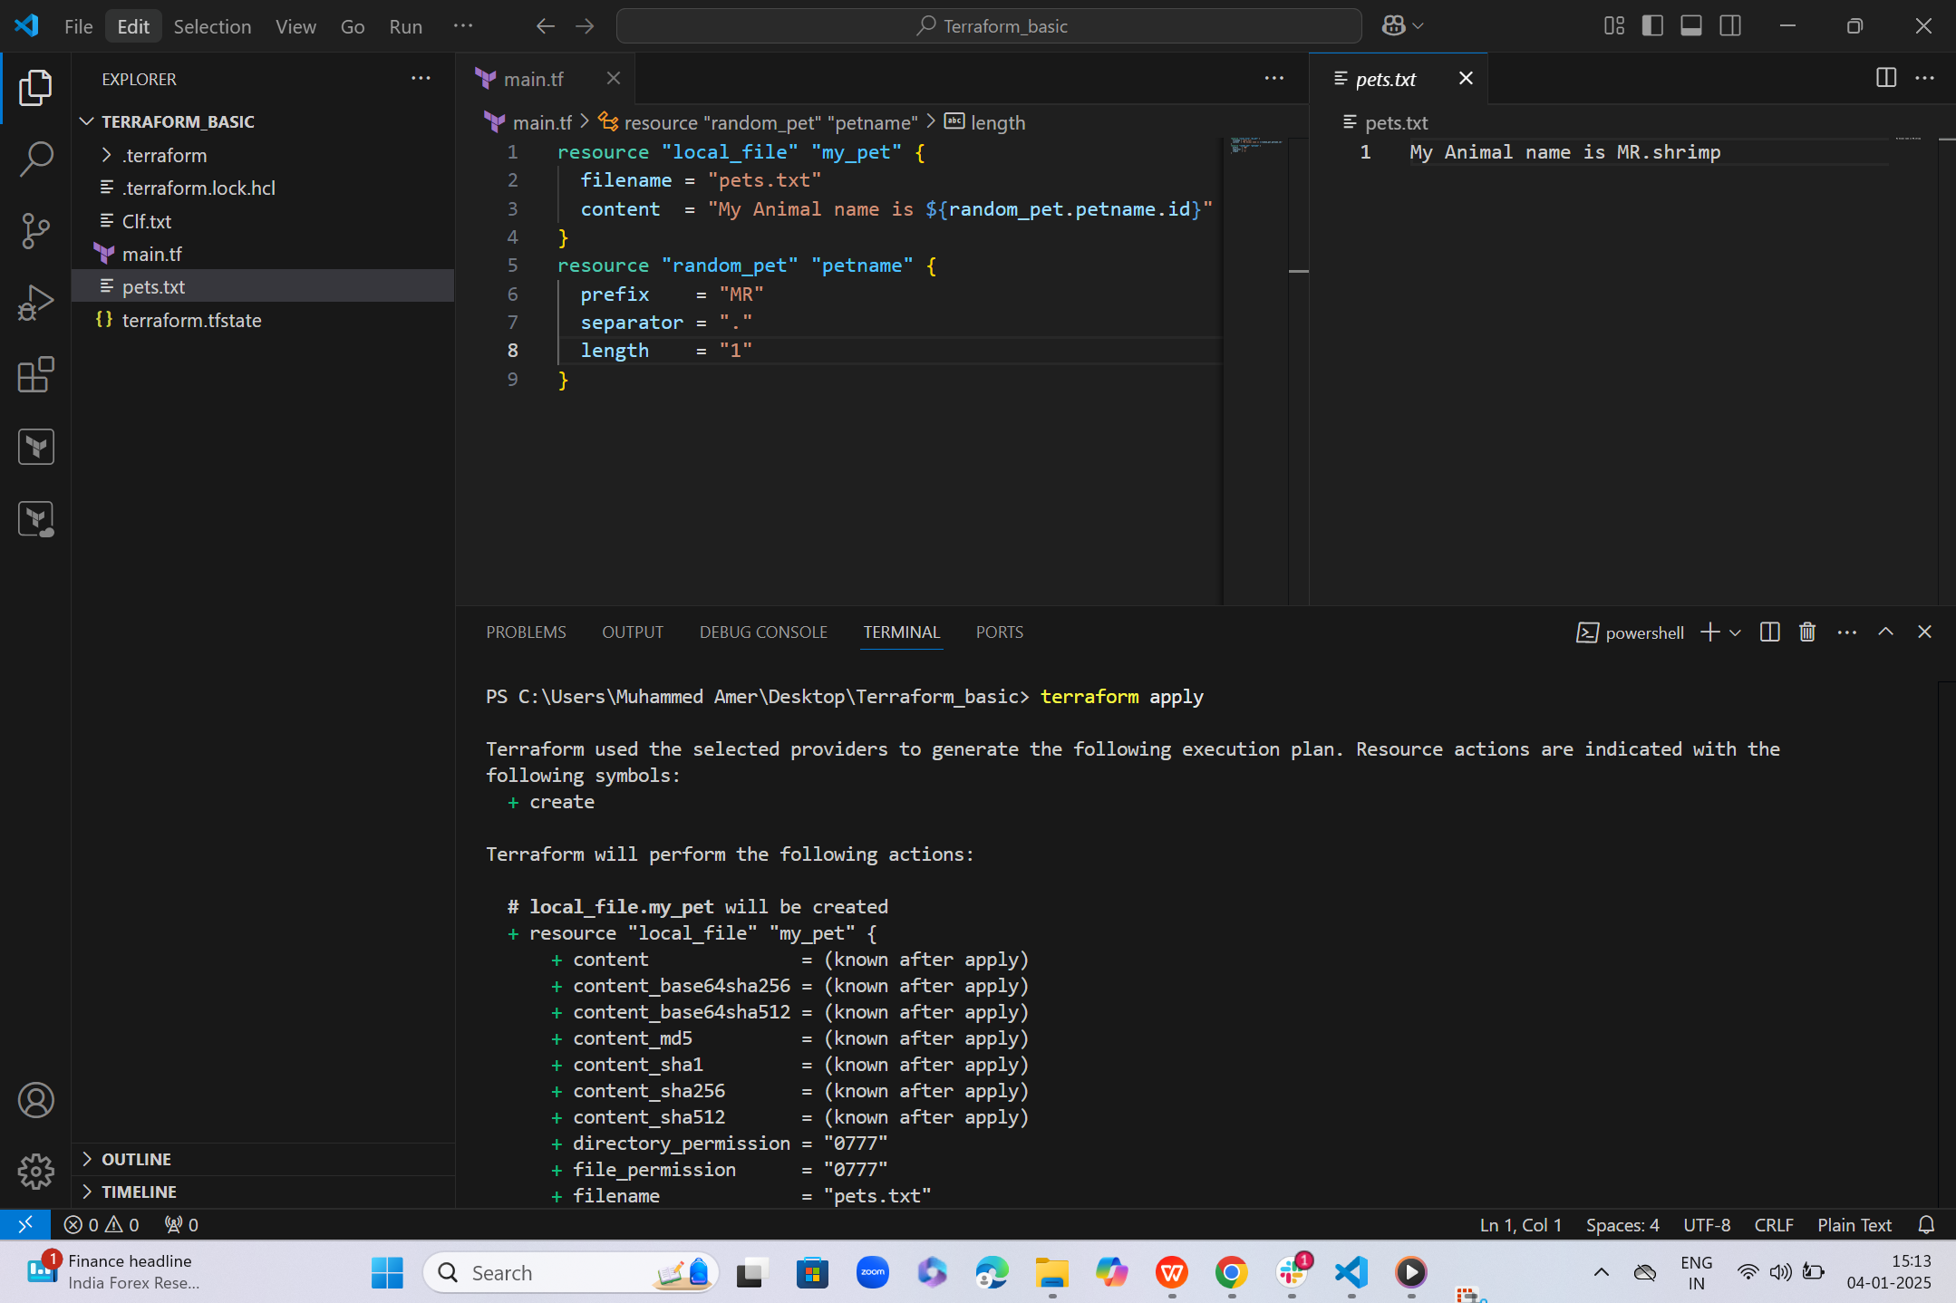  
     
     
   **Terraform-Output**  
     
   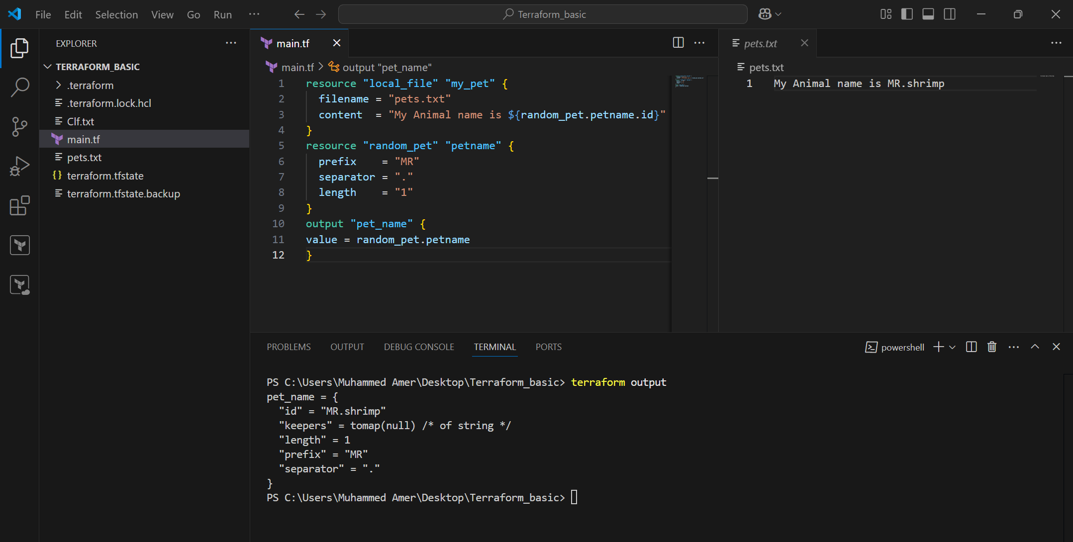  
     
     
     
     
     
     
     
     
     
     
     
   Terraform Versions -- Download exact version  
     
   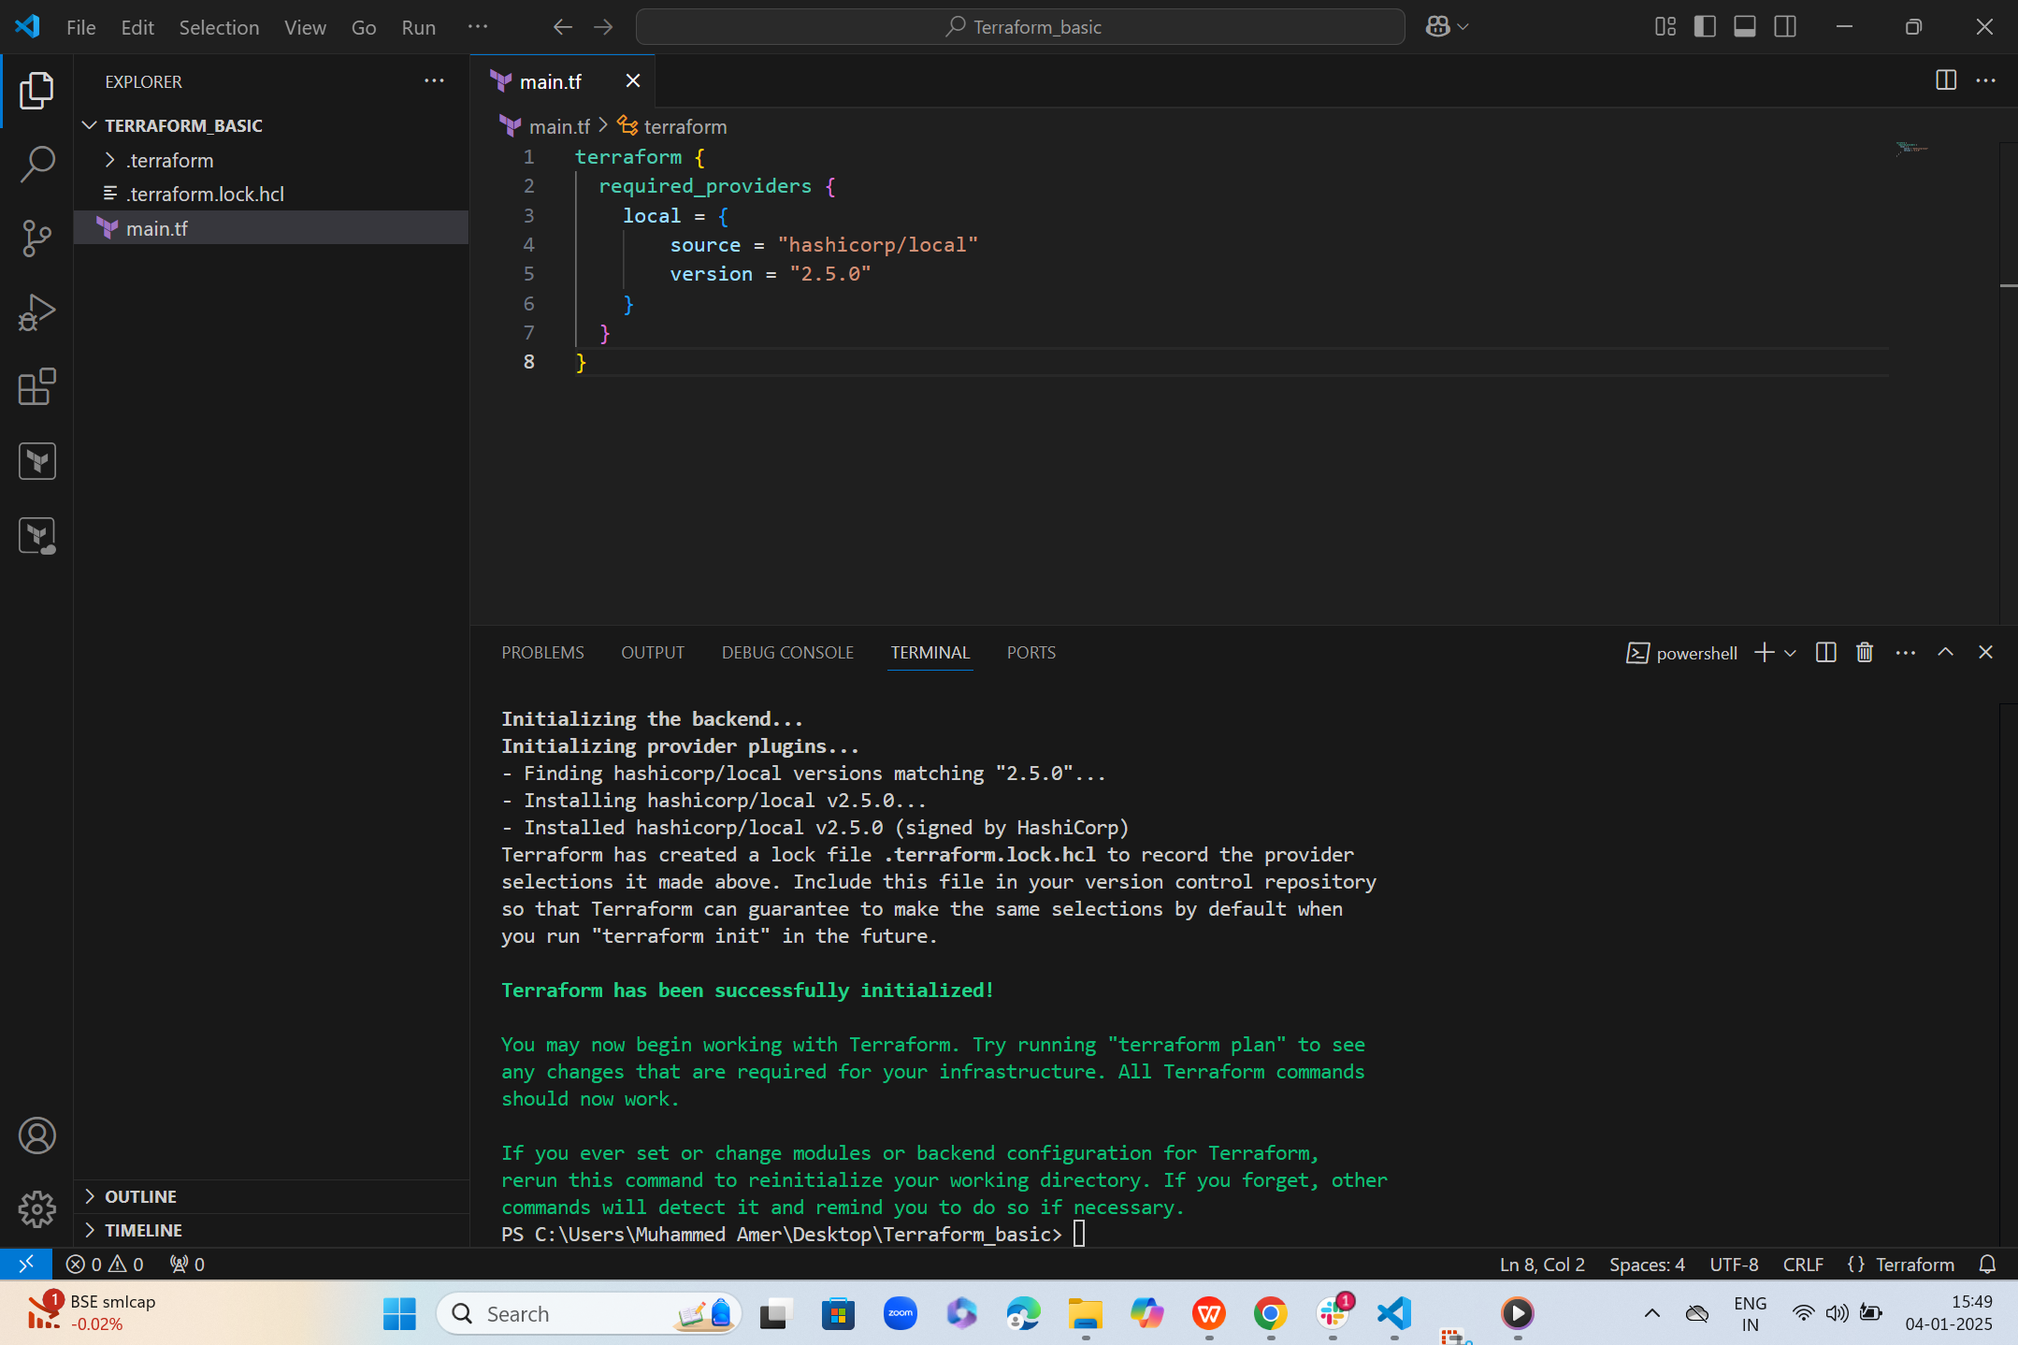  
     
     
   ! = Will not use the mentioned version  
     
   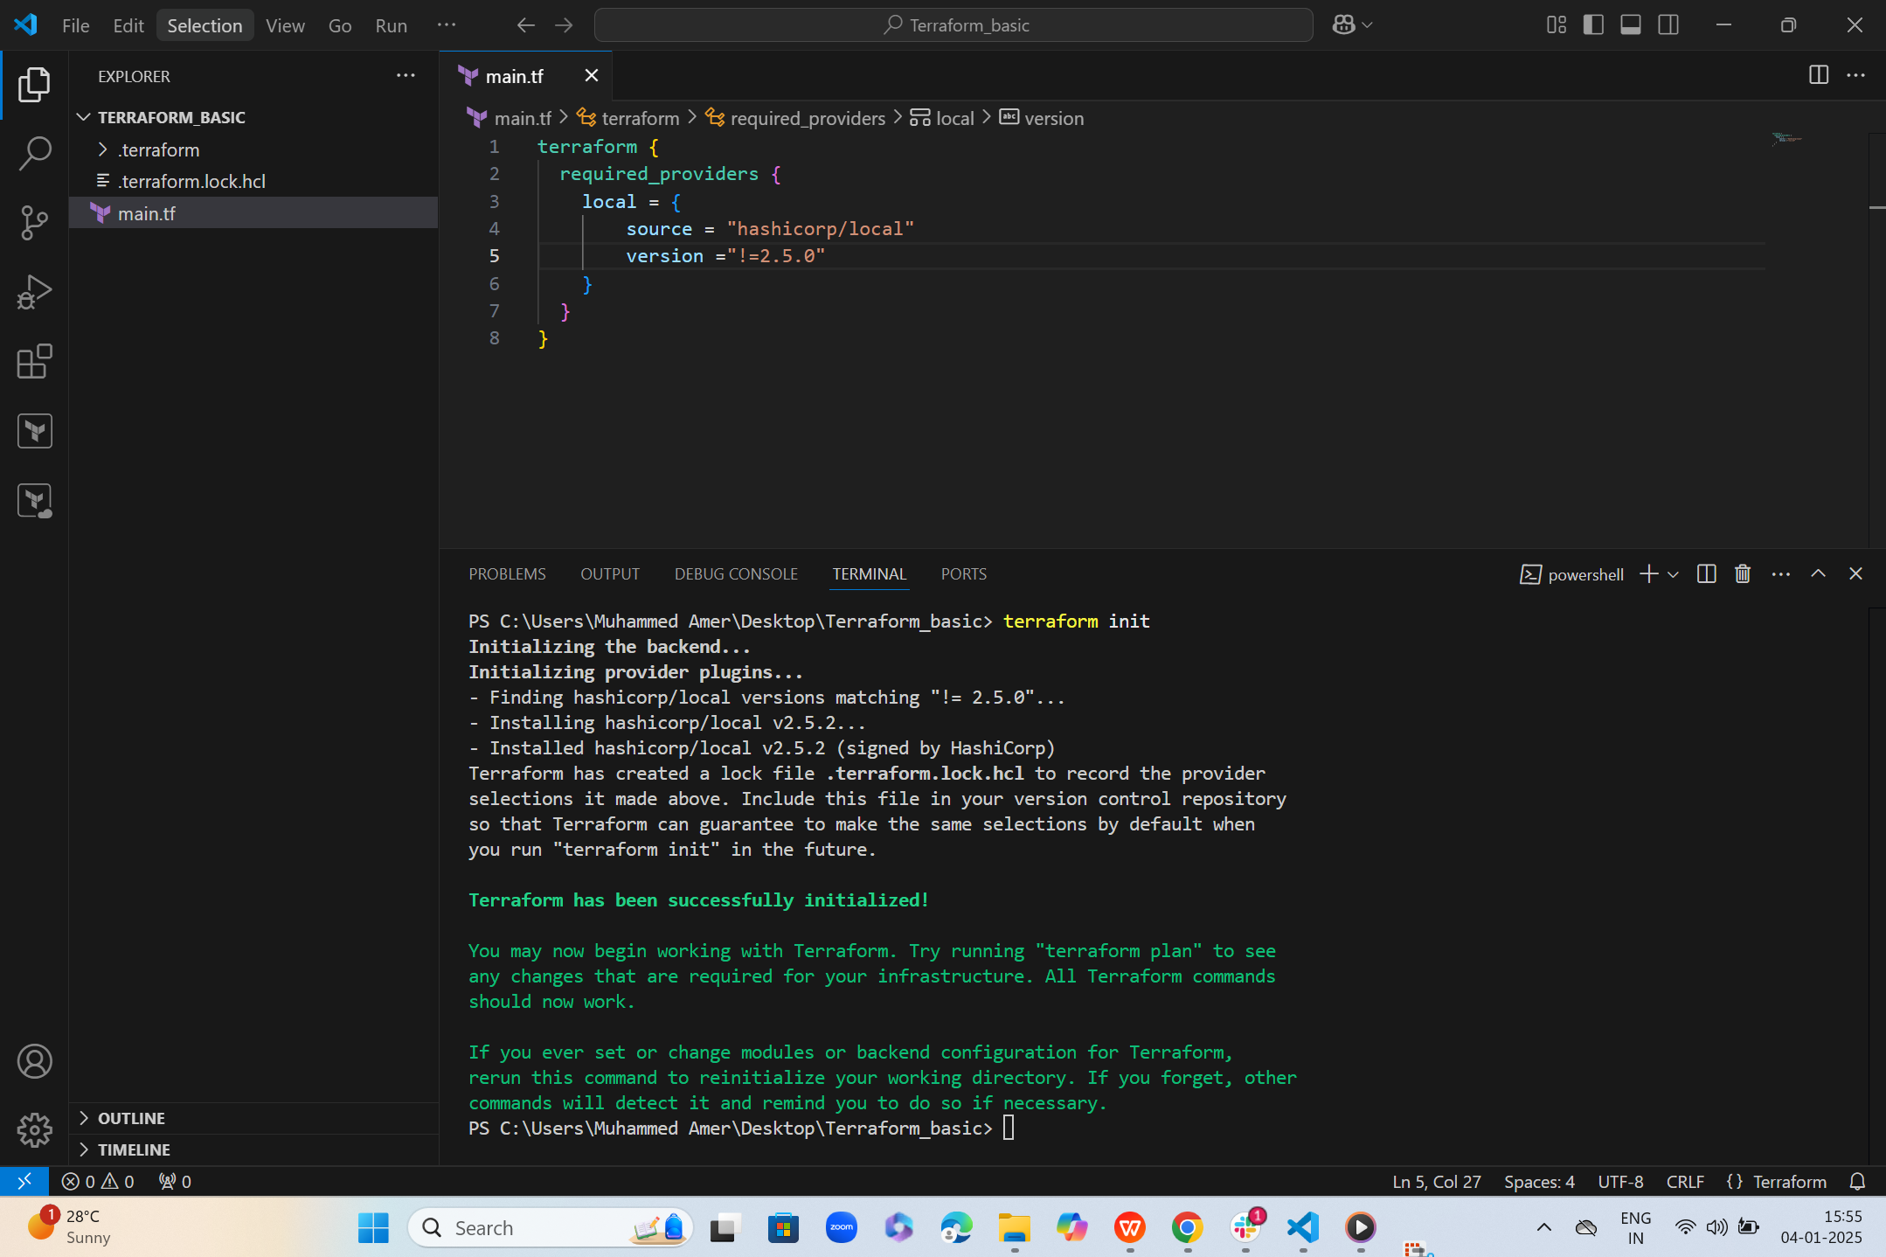  
     
     
     
     
     
   < - lesses then the mentioned version  
     
   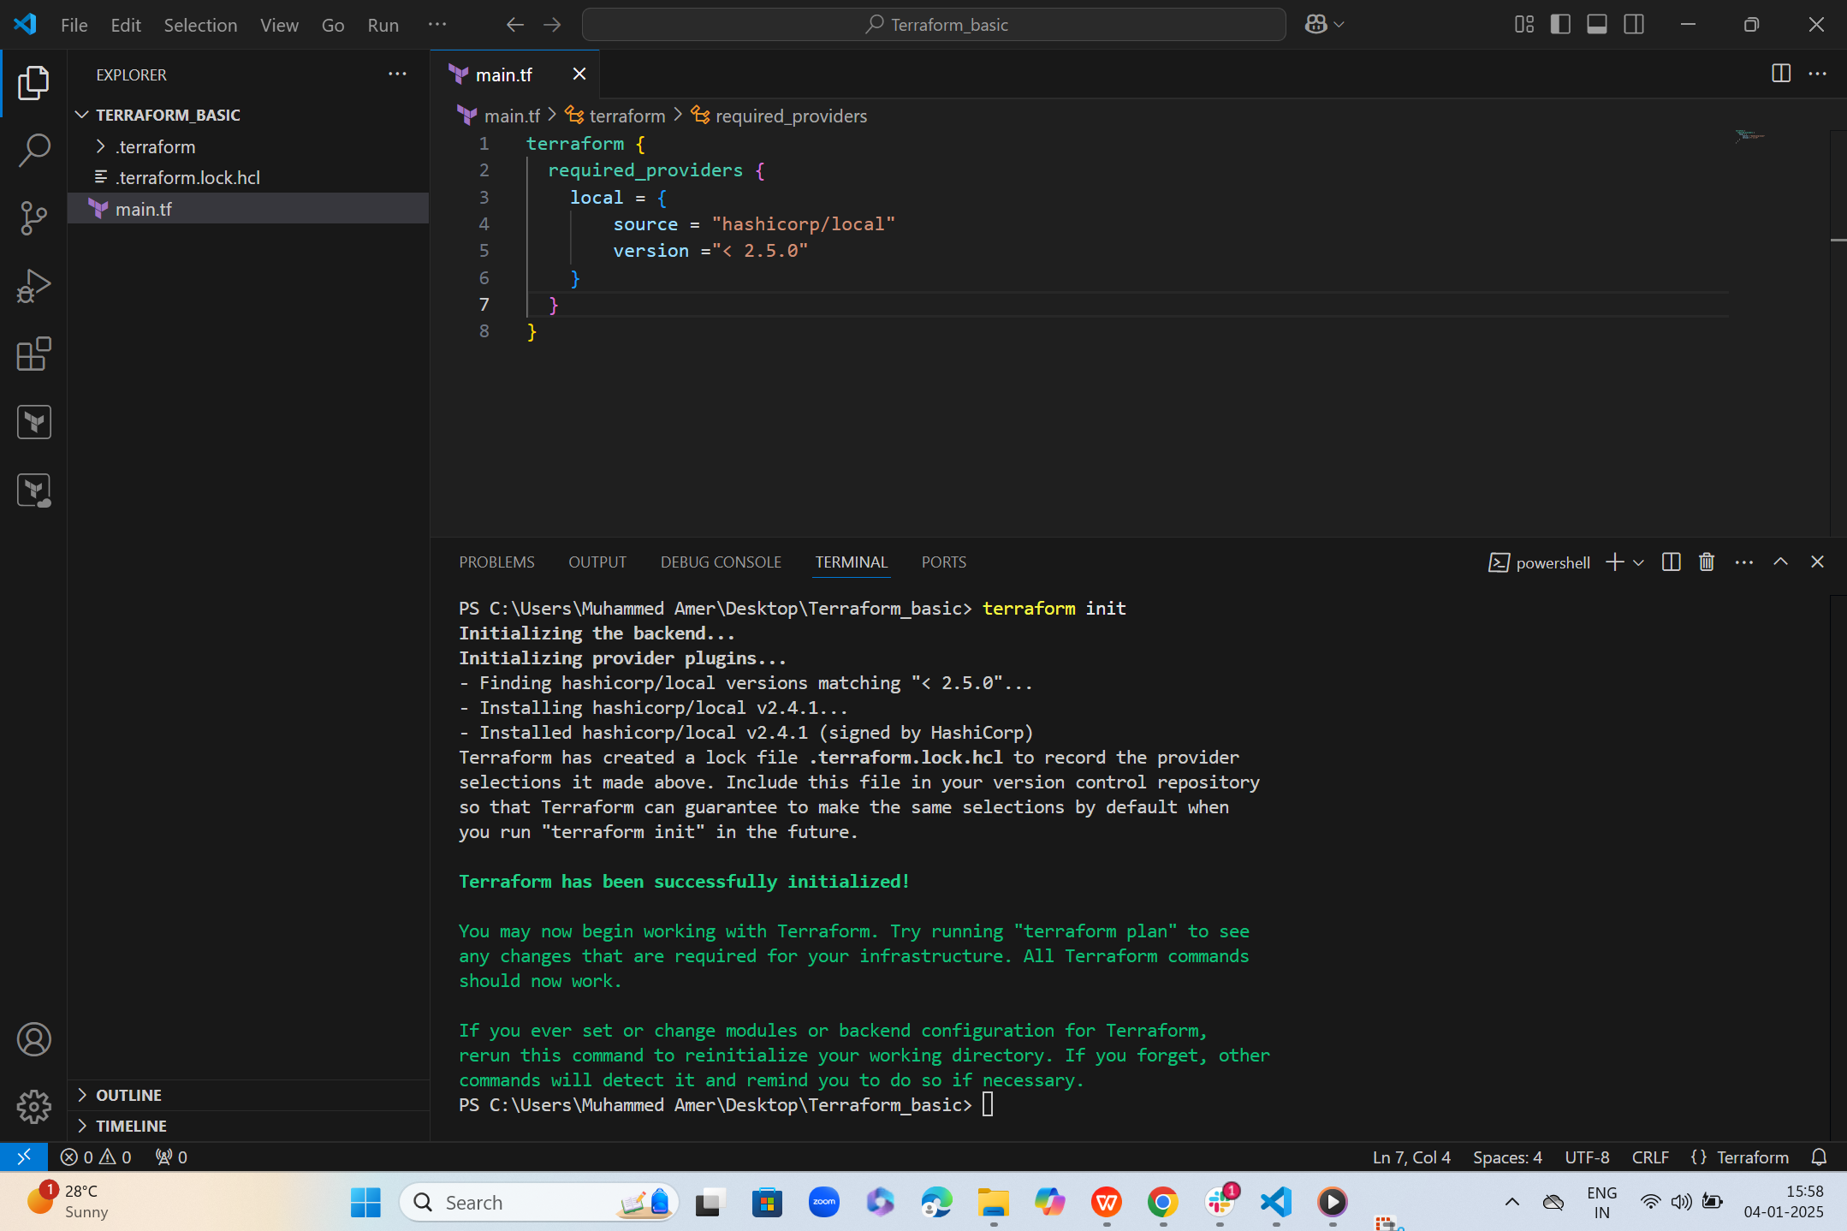  
     
     
   > Greater then the given version  
     
   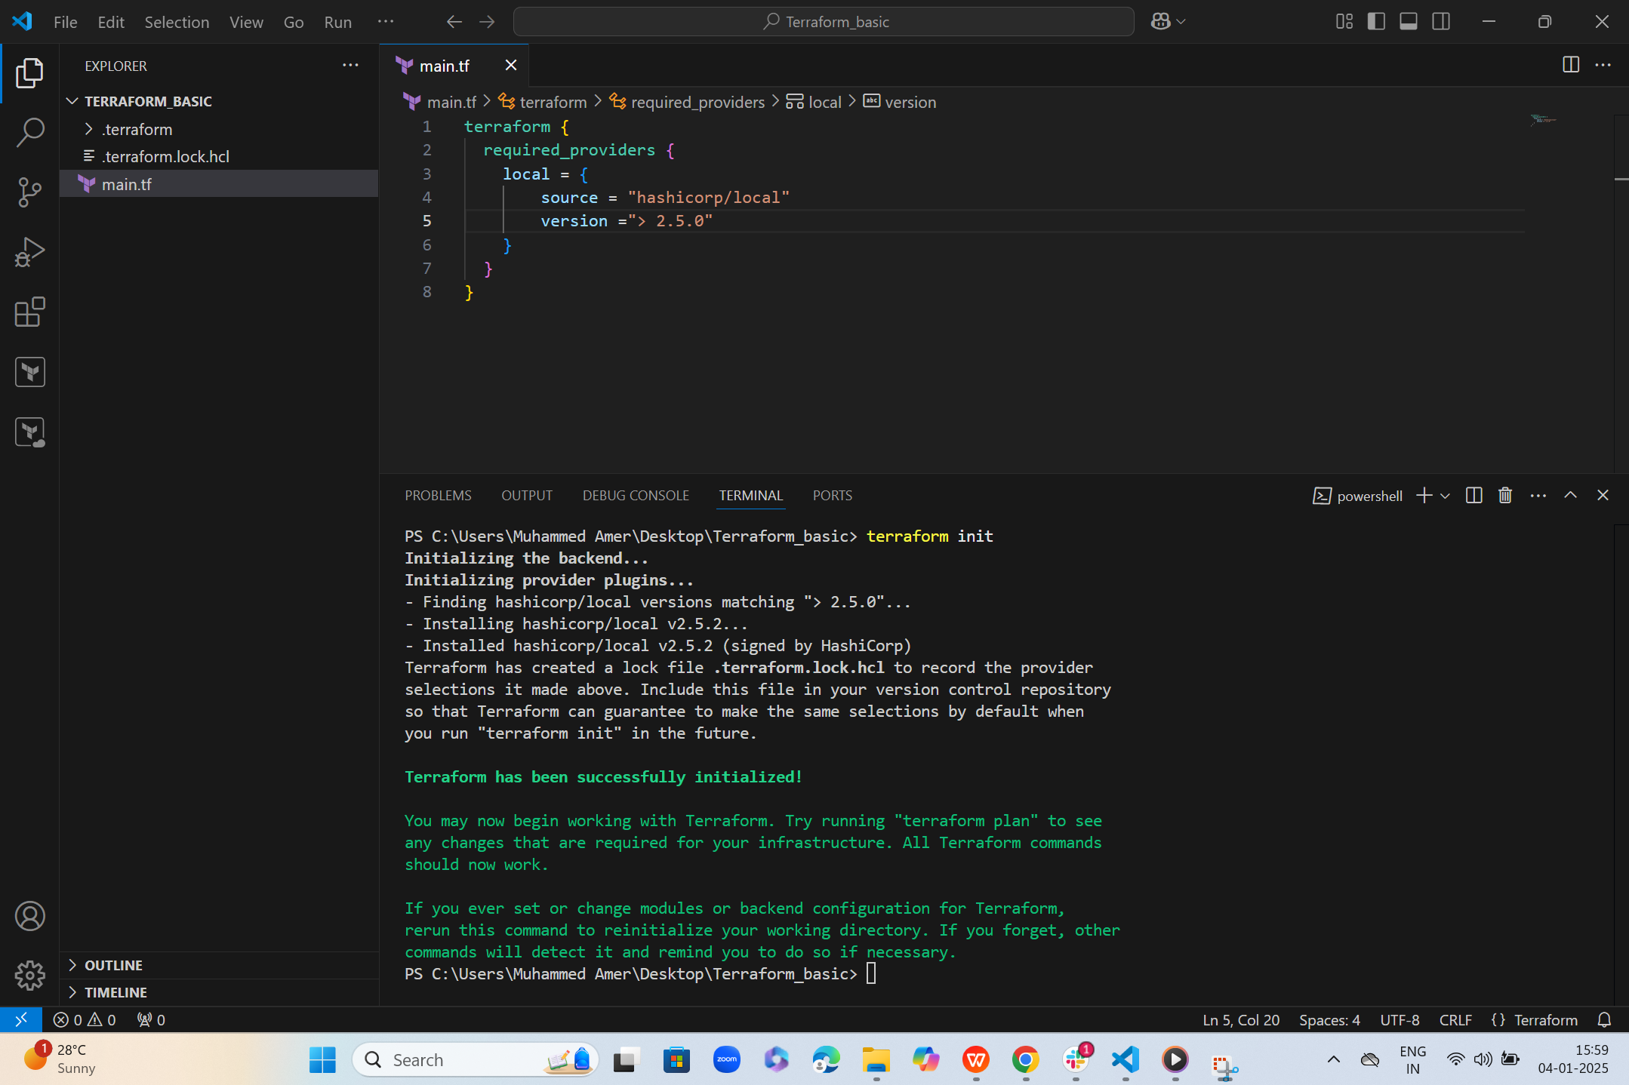  
     
     
     
     
     
   ~ Specific version or higher version  
     
   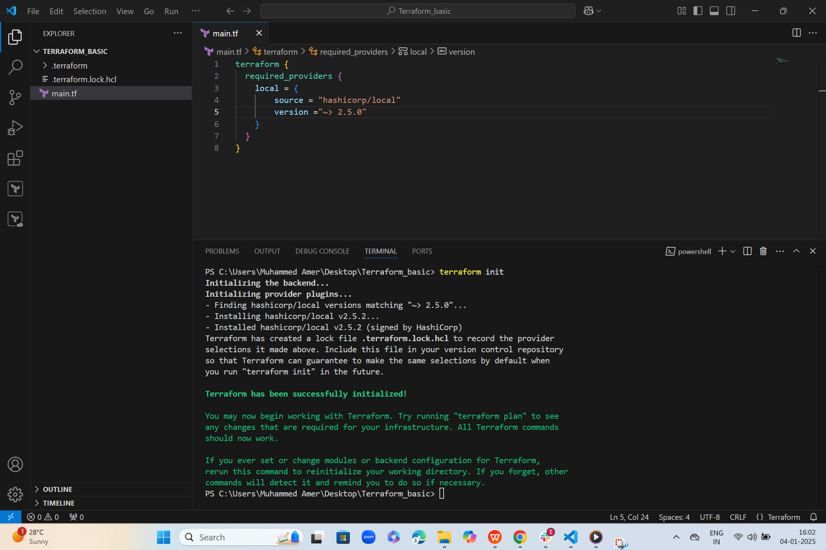  
     
     
   **Data - Source**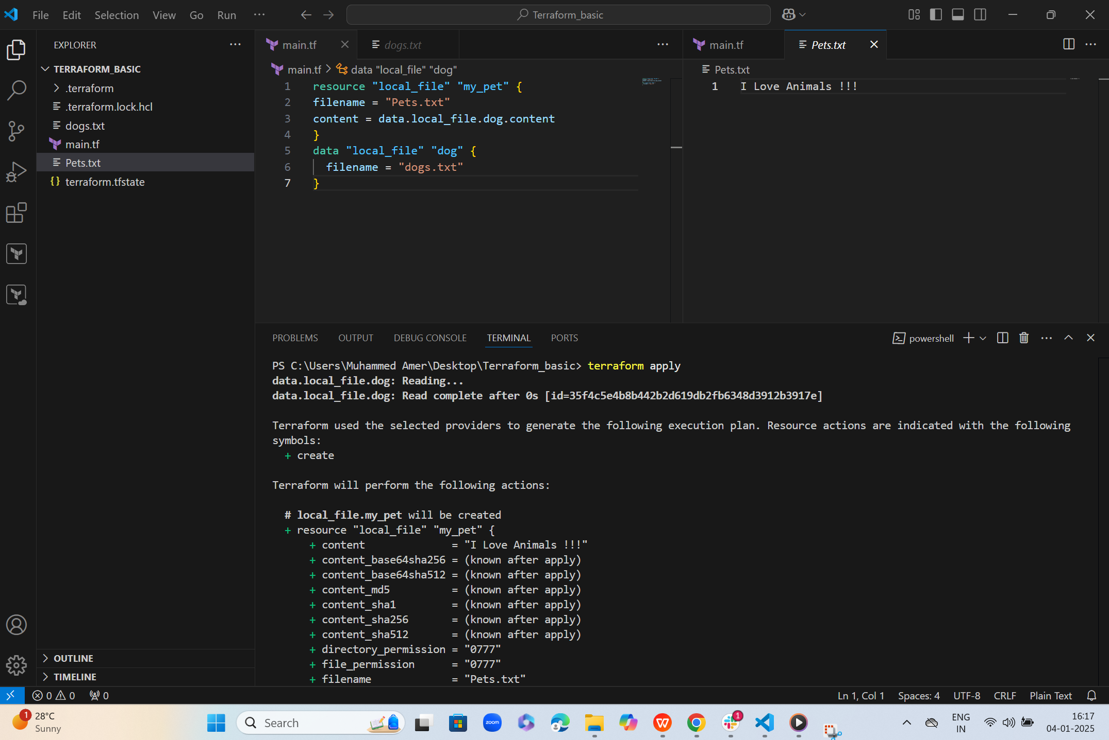  
     
     
     
     
     
   AWS-CONFIGURE  
     
   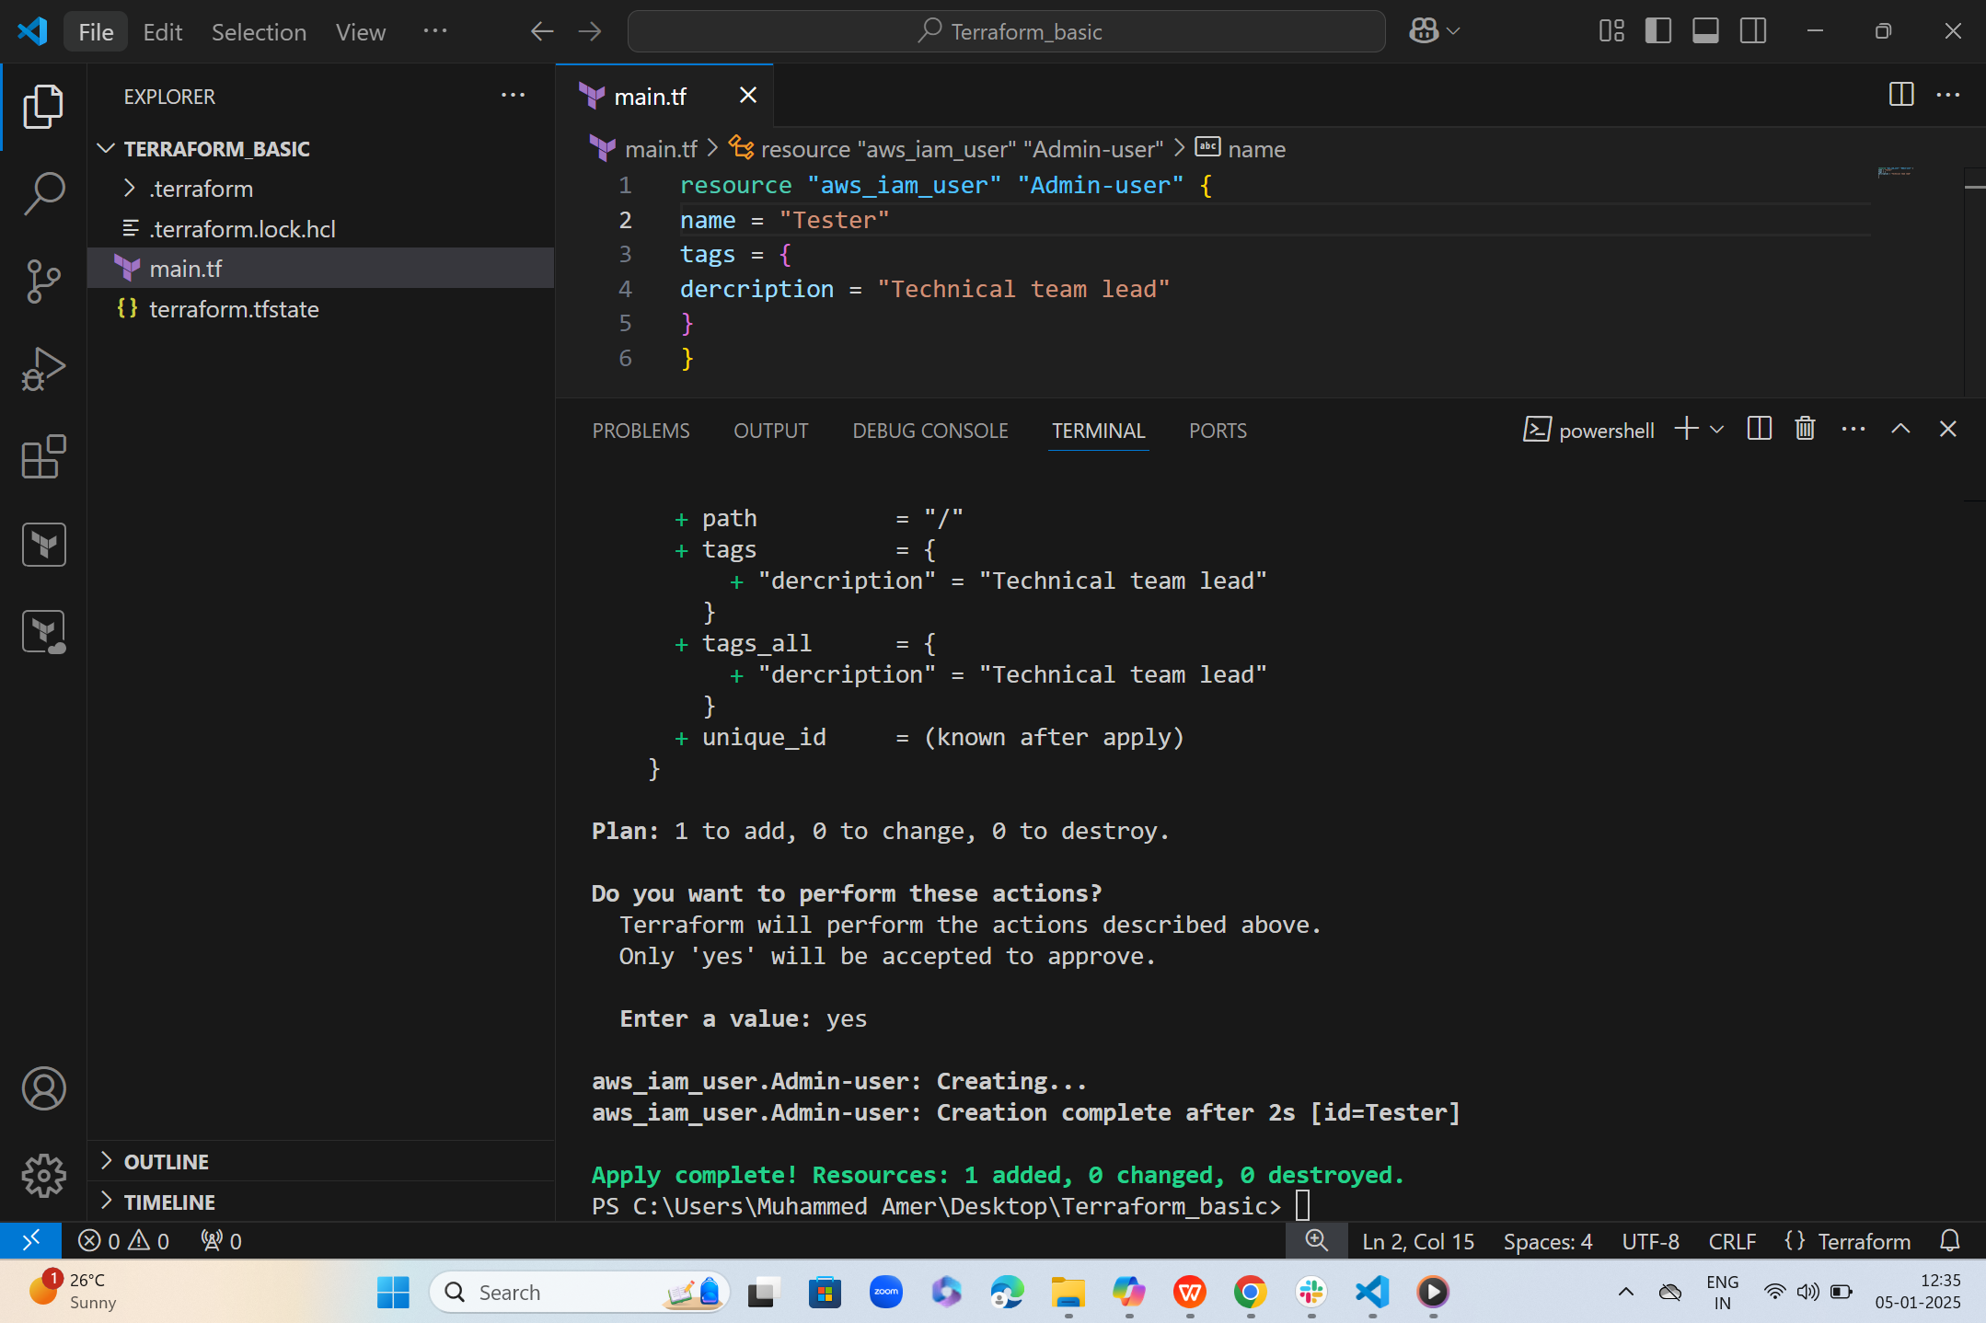  
     
   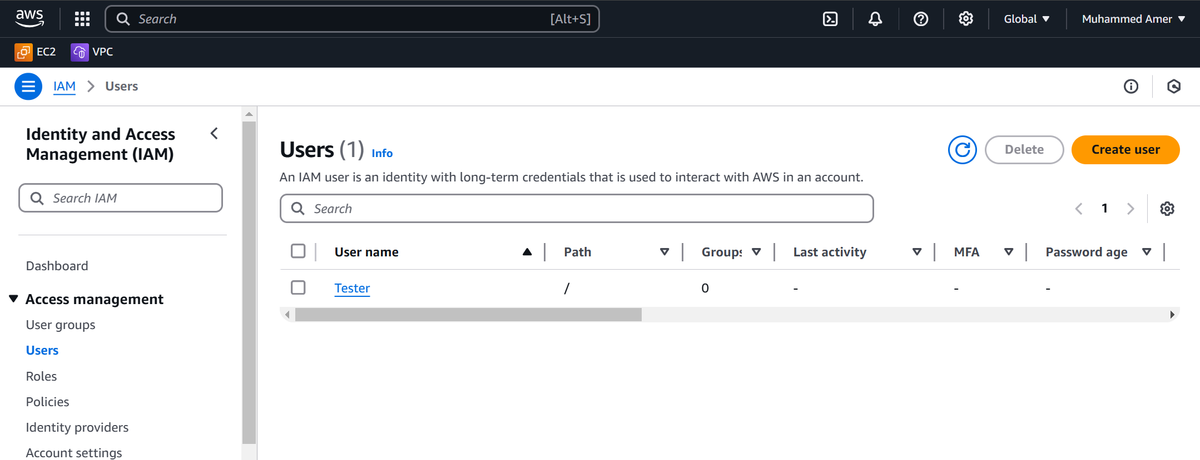  
     
     
     
     
     
     
     
     
     
     
     
     
     
     
     
     
     
     
   **Creating**  
     
   AWS_USER  
   AWS_POLICY

ATTACHING_POLICY_WITH_USER  
  
  
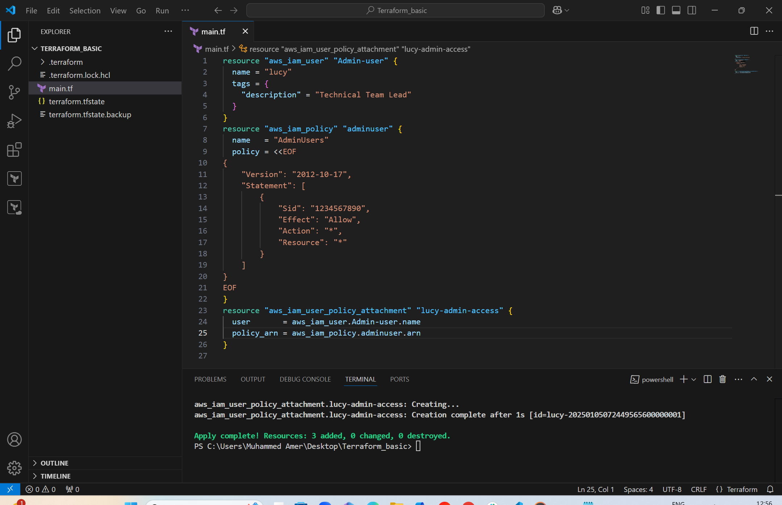  
  
  
  
  
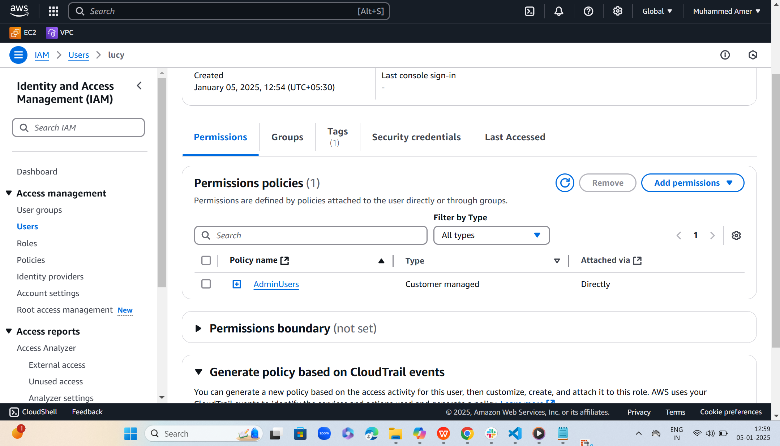  
  
  
  
3) Intergrate terrafrom in jenkins using Terraform plugin.   
  
4) Create one jenkins job using MAVEN PROJECT for the below code with two stages. stage 1: Git clone stage 2: Maven Compilation Code: [https://github.com/betawins/java-Working-app.git](https://github.com/betawins/java-Working-app.git" \t "https://app.slack.com/client/T03TRQ064Q0/_blank)   
5) Use the below code and create a parameterized job in jenkins stage 1: Git clone stage 2: Maven Compilation Code: [https://github.com/betawins/java-Working-app.git](https://github.com/betawins/java-Working-app.git" \t "https://app.slack.com/client/T03TRQ064Q0/_blank)   
6) What are the global varaiables in jenkins?   
7) Watch terraform-04 video.   
8) Execute the script shown in video.   
9) Integrate terrafrom in jenkins using Terraform plugin.   
10) Create CICD pipeline for Nodejs Application. [https://github.com/betawins/Trading-UI.git](https://github.com/betawins/Trading-UI.git" \t "https://app.slack.com/client/T03TRQ064Q0/_blank) 11) Explain 10 Maven commands.